**Lec 011**

Unit impulse (Delta) function

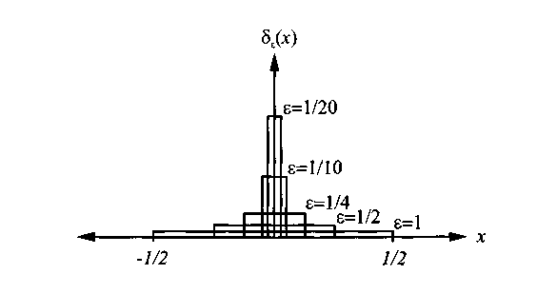

Delta function plots



For any continuous function,



Unit step function



Using the definition of unit step function, we can write the CDF of  as

.

The PDF of the discrete random variable  is



The expected value of X using the above function, we can write as



**Mixed random variables**

*  is a mixed random variable iff (if and only if) contains both **impulses** **and nonzero finite values**.

EX 3.21) Given the CDF function shown as



Find the PDF and.

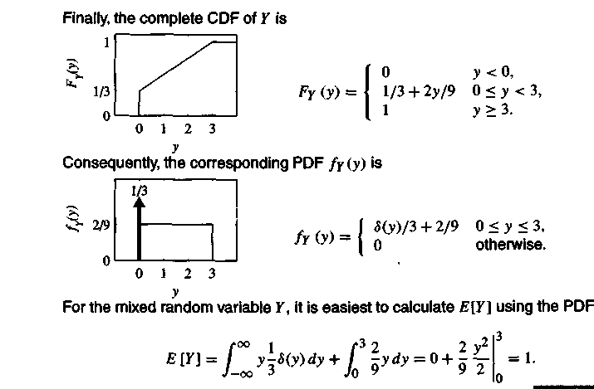

* always has a CDF **
* If  is piecewise flat with discontinuous jumps, then  is discrete.
* If  is a continuous function, then  is continuous random variable.
* If  is a piecewise continuous function with discontinuities, then  is mixed random variable.
* When  is discrete or mixed, the PDF  contains one or more delta functions.

Quiz 3.6 The cumulative distribution function of random variable  is



Sketch the CDF and find the following:

(1) P[ 1] (2) P[ < 1]

(3)P[ = l] (4) PDF 

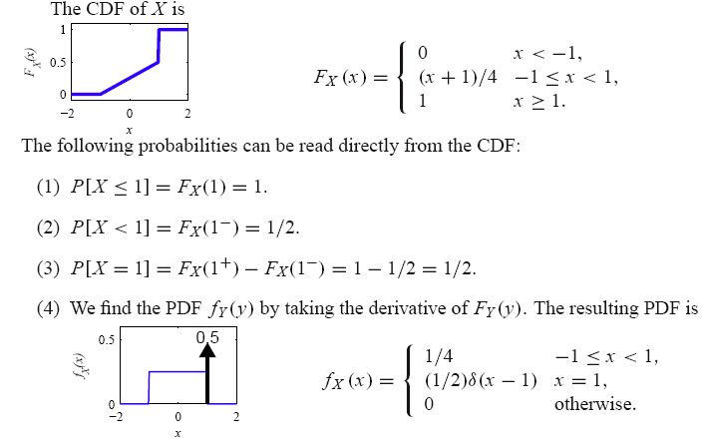



It is uniform in the range  and it’s amplitude is 1/4.

1. What is the probability density function?
2. Write and plot the cumulative distribution function?



b)



**-1**

**1/4**

**1**







**-1**

**1/4**

**1**

**Probability model of derived random variables**

If , then we talk about the methods of determination  from  and. In this case we take two steps to as follows

1. Find the CDF 
2. Compute the PDF by calculating the derivative 

Ex 3.22) The function  and  are given as below



Find the CDF  and.







* Note:  is the **uniform (0,100)** random variable.

If , where , then  has CDF and PDF as follow







If , then  has CDF and PDF as follow





